Annual Report A.S.V. Kwakiutl 2020-2021
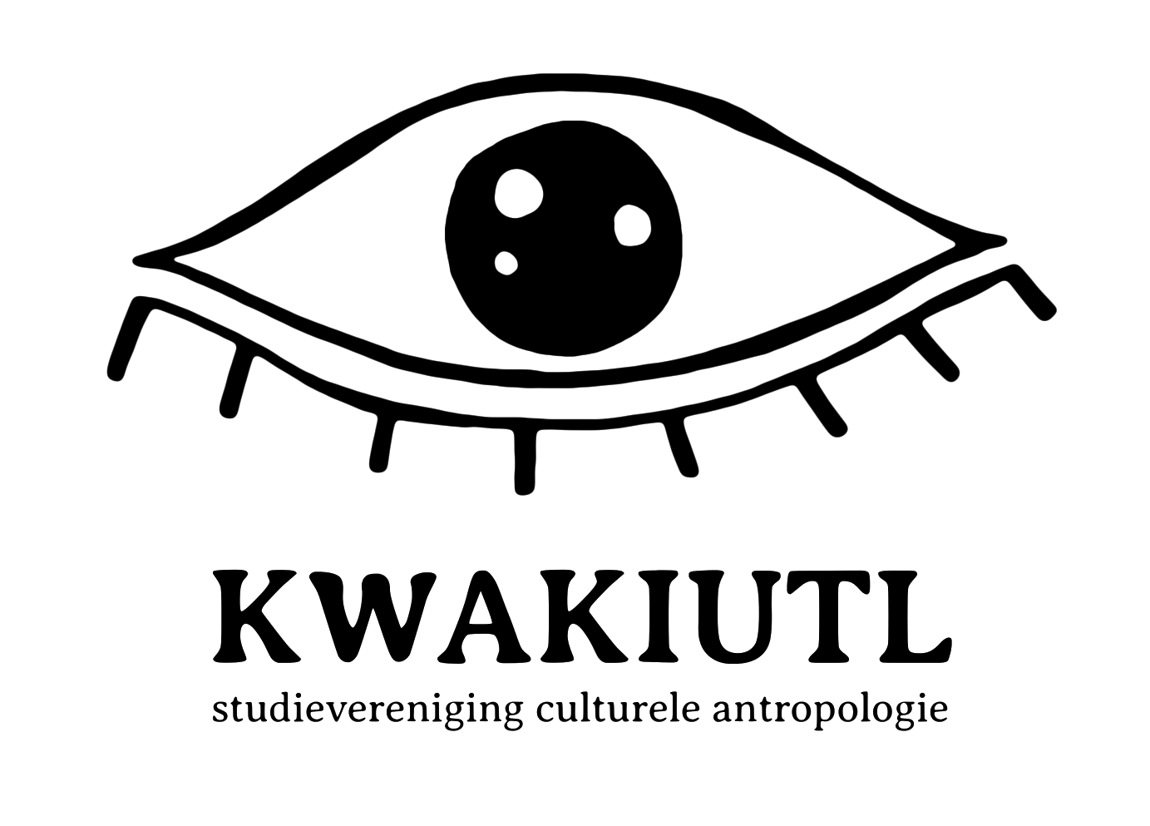

Chair Veronique Bon
Secretary Iris van Dockum
Treasurer Marijn Beertje Broek
Social Coordinator Marijn Groeneveldt
Study Coordinator Moena Geddi

Content

- Introduction

- Goals
2.1 Focus point 1: Kwakiutl for their members
2.1.1 Internationalization: Connection between our national and international students
2.1.2 Safety for our members: What are can we do against sexual
harassment?
2.1.3 Link between years
2.1.4 COVID-19
2.2 Focus point 2: Collaboration
2.2.1 Collaboration between Kwakiutl and other institutions
2.2.2 Collaboration between students and lecturers

- Goals per function
3.1.1. Chair: Veronique Bon
3.1.2. Secretary: Iris van Dockum
3.1.3. Treasurer: Marijn Broek
3.1.4.Study trip coordinator: Marijn Broek
3.1.5 Coordinator of Study: Moena Geddi
3.1.6 Coordinator of Social Activities: Marijn Groeneveldt

- Introduction

Dearest Members,
What a year it has been. We started the year very enthusiastic with lots of ideas for themed parties, travel places and positive changes for Kwakiutl. Unfortunately, this global pandemic lasted longer than we had hoped and we mostly had to organize all our events online instead of meeting each other. Even still we had a lot of fun hosting all the events we created togethers with our committees. We used this policy plan to guide us throughout our board year and have written down what we have achieved and what we can give as points of improvement for the new board.
This year was a crazy adventure in which we have enjoyed every part of.

Lots of love,

The Board of 2020 – 2021

- Goals

2.1.1 Internationalization: Connection between our national and international students

Looking back on the integration of our new international members, we feel like we did what we could. At the beginning of the year it was easier; with the introduction week, our First years weekend and the weekly borrels. We happily noticed a lot of international students attending our events and mingling with other members. Another thing we’ve noticed is a lot of international members joining our committees, which according to us is a great way to mingle and meet others, so we’re very glad to see that, too. Furthermore with the large decrease in members joining online events, the integration of international members is not what it would have been in a normal year. However, we feel like we’ve achieved the most we could and see a lot of international and Dutch first year finding each other and becoming friends.

2.1.2 Belonging & Inclusion; more attention to boundaries

At the beginning of the year we assigned a trust person within our board, Marijn Beer, who would be a point of contact for our members if they were troubled with anything. To make contact easier, we also made an email address so people could also send an email if they didn’t feel comfortable approaching Marijn Beer in person. Last year, no members have taken usage of the email address but we have dealt with some situations at events which were dealt with accordingly. We reckon there was not much activity with the trust person because we have had trouble building an intimate connection with our members because of our COVID influenced year.

Even though most of our events have been online events, we have always taken into account that the (online) space should be safe and easily accessible for everyone who would want to join. All our events were in English and we tried to focus our promotion on every one of our members, without excluding anyone. We have always tried to make an effort to make sure everyone felt safe and felt like they could speak and act freely. We hope our members saw our efforts and indeed felt comfortable at our events. When in-life events were happening more we could act this policy out better.

2.1.3 Link between years

As far as the mingling of the different yearlayers, we feel like there is more to achieve on this point. As stated in our initial policy plan, we already expected this to be a bigger challenge than usual because of the lack of offline meeting opportunities. At the beginning of this year, when offline meetings were still possible in some forms, we did see this happening. There was a lot of mingling, and different members from different years, nationalities and ages were all making acquaintance. However, a major part of our committees is filled with first year international students, what we love, but keeps them from mingling with others now the offline meetings are not there anymore.
We did not succeed in our plan to use the common room as a meeting point; there were too little people allowed in at the same time, which made the organization of such an event a problem.
Luckily, we do have our student mentors, who we appreciate even more in these times. They really are a point of contact between first years and older years; whether it is for study related questions or just to have a chat.

2.1.4. COVID-19

At the start of our board year we wanted to organise onsite activities as much as possible while we still could. We had a lot of luck that we could organise borrels and a first year trip in real life. But when measures tightened we feel like we took a bit too long adjusting to online activities. With four months of lockdown in which we had every event online in april we could start with organising on site events again. Our borrels could take place again and we organised multiple events in real life.

2.2.1 Collaboration between Kwakiutl and other institutions

With Veronique being a part of the FMG board, Iris being a part of the LaSSA and Moena being part of the ANCA we’ve kept in good contact with all organisations. We organised a congress with the LaSSA which was great and this coming year we are organising the Namgis congress with the help of ANCA and we will be having other events in collaboration with the FMG. We have made good contact with SEC but unfortunately as of this moment we can not organise an open mic event together.

2.2.2 Collaboration between students and teachers
This started out very well, we engaged our teachers in all our events, by inviting them and keeping them posted on what we were doing. We appointed one teacher to function as a bridge between Kwakiutl and the teachers, we would always keep him involved so it would be easier to reach other teachers through him. Sadly when classes went online again and the UvA closed, this also diluted, because it is harder to communicate when you never see each other in real life. When there is an event we still reach out to teachers and we hope to still see them at our (online) events the upcoming half year!

- Goals per function

3.1.1 Chair - Veronique Bon

My main goal as chair was to have a safe and open environment between our board members. We started this year with already being friends but I think this half of the board year has only helped our friendship grow. I’ve tried to plan for us to see each other at least once a week without doing board stuff to maintain our friendship. When we shifted to online Kwakiutl events we would sometimes do this together but we found that it is not the best for other members to see us together on one screen having fun off camera. I’ve tried to organise our board meetings in real life so we could really see each other during board activities as well to make us working together feel as organic as possible. I started calling all members on Friday’s to have a weekly chat about board life and in the upcoming half year I want to pass this on the next chair as it has been a great way to know how everyone feels and it is a good indicator on how everyone is doing week by week. With restrictions and lockdown it has been very hard for me to show my face to general members and keep close contact. I hope with the post we put out on social media members can still get to know me a little. I have been very active in getting to know all other boards of the FMG so we can keep in close contact to share our tips and tricks with each other.
The open door policy we wanted to create has been difficult due to the fact that from October on general members were not allowed to be in the boardroom. We found out it is too impractical to find a café close by and sit there, but I have been trying to spot members when walking around and offer them coffee as much as I could. It is not much but with little resources the only thing I was still able to do to maintain contact.
FMG
As chair I also have a position in the faculty association of social and behavioral sciences, the Fv-FMG. I have mostly been working on the study active certificate, SAC. This is a certificate study associations can hand out to its members when they have been actively involved in the association. I hope that we can start handing them out this year to give members some kind of gratification for being a member, especially during these corona times when motivation is very hard to find. I also have been working on acquisition for the FMG party and activity.

Hunsel
With all the restrictions and COVID-19 measurements it is hard to organise an event like the Hunsel weekend. With Iris helping me with this event we have decided not to form a committee because it can easily be canceled and we found it to be too much of a hassle to get a whole committee going instead of us working a bit harder for two weeks if we can actually organise it. If so we’ve learned from our first year trip to make the registration period as smooth as possible. Unfortunately the covid restrictions made it impossible for us to organise this event.

Chair – Veronique Bon

3.1.2 Secretary - Iris van Dockum
As a secretary I wanted to make sure that there is a smooth and clear communication between our board, other associations and sources. I think last year that worked out pretty well by keeping up with our email and keeping our socials up-to-date. My goal was to be active on our social media platforms. We spiced our socials a bit up with some colorful templates to attract attention. I especially want to use our website more because I might have focussed too much on our social media platforms instead of using our website as the main source. For promotion and updates we created a new actual tab on our website and created a kwaktual on whatsapp to reach our members without social media. Together with Beer I made sure our memberbase is completely up to date with conscribo because we saw some differences in the two programmes.

Besides my job as a secretary my focus was on our new international member’s. I’m happy I had the opportunity to help some internationals for their application. Unfortunately I couldn’t really organize a lot of events to assure assimilation but I think with our events we showed both dutch and international members are more than welcome. It was great to see how these both sides mixed. Unfortunately I couldn’t meet a lot of members face to face due to the corona measurements. Either way I hope everyone feels welcome and wants to meet up in real life when we get the chance.

Besides being a board member of kwakiutl I had the honor to be a general member of the LaSSa with Merijn Olij. Together with the other anthropology associations we hosted our first very successful event; the positivity congress. It’s nice to keep in contact with other associations during these difficult times to get inspired and hype each other up.

Overall I feel like me and my board have done the best we could. It was hard to keep motivation and keep people excited for kwakiutl during corona times. I’m happy to see that the members of kwakiutl definitely did not forget kwakiutl even though the attendance at events was not alway what we expected. We totally understand that it’s hard to attend online events after a whole day of online classes. The events we were able to organize in real life were really successful, everyone was really happy to see each other in real life. I hope next year the new board is able to keep everyone close to the association.

Secretary 2020-2021 Iris van Dockum

3.1.3. Treasurer: Marijn Beer

This has been a quiet year for Kwakiutl and this can be seen as well in our Annual Financial Statement. During our half-year report I wrote down that we haven’t made a lot of expenses yet but hoped to do so more in the next half year. This has fortunately worked out well and we had the chance to organize some amazing online and offline events for our members from January onward. This meant more expenses as well and I got a little busier. I enjoyed this very much as I could work more on perfecting my accounting skills and saw great events bloom right in front of me.

I had no more troubles with my function and I felt that through good communication with my board and keeping an eye on our budget, we had a great last few months as the 34th board. The only trouble I still experienced was when we didn’t get our money back from Transavia when cancelling our flight tickets for the study trip. I found that communicating with them was extremely difficult and due to their unfair policy, we lost some money here. This fortunately got worked out with the administrator of our faculty so there is no real harm done to the association.

This year, I chaired the Acquisition committee and we made real progress with setting up a format for upcoming years. We mostly worked on exploring different ways of doing acquisition and we set up guidelines for the next generation to have as fundamentals. Because of COVID, no companies were interested in collaboration and it was particularly hard to make connections because we started from nothing. I strongly encourage the upcoming board to set up an Acquisition committee again as it helps the association's network and can help get extra funds for the association.

Lastly, we experienced a lot of difficulty with spending up all our money, as we could only do real-life events again very late in our year. This means we have a lot of subsidy money as well as member contributions left. What we have left from the subsidy money we have to give back to the UvA but in consultation with our administrator what we have left this year won't influence the subsidy we will get next year, as this was a COVID influenced year. What we have left from member contributions I will transfer to the next board as this money has to still be spent on our members. My advice on using this money would be to put it in the Lustrum events this year, making it one to remember.

This concluded my annual report,

Marijn Broek - Treasurer

3.1.4 Coordinator of Travels: shared function

We started in oktober with a plan to travel to Slovenia for ten days in May. We made a lot of progress fast because we could cheat looking at the information we gained last year. Everyone was really excited but we also kept in mind that the trip might not go through. Which was exactly the case. Due to stricter COVID-19 measures and us not wanting to be dissapointed last second, we decided to cancel the trip to Slovenia. We tried to organize a more small-scale trip in The Netherlands but this turned out to be too ambitious as well so we sadly had to cancel that too. I do want to thank my committee for their hard work and continuing enthusiasm throughout the duration of the year.

This concludes my annual report,

Coordinator of Travels: shared function - Marijn Broek

3.1.6 Coordinator of Study: Moena Geddi
This first half year has certainly challenged me, as a board member, to think outside of the box. It forced me to get creative in organizing events in any way that was still possible. So far event planning has thus been difficult, but I got the hang of things and there are some amazing events coming up! Because everything right now is so different than anybody has ever experienced, I felt it took some time to really get into my role as a coordinator of this many committees. I didn’t (and still don’t) want to ask too much of my committee members because we’re amidst a pandemic and not everybody is feeling great right now. I want to make being in a committee as fun as possible, but this means that I accidentally tried to organize everything by myself. I recently found more balance in keeping my committee fun, but still delegating tasks. Still, I am just as excited about organizing cool and educational events for Kwakiutl as at the start of the year.
Buddy system
The buddy system started out great with many enthusiastic older year students, who wanted to help the first year students to get to know Amsterdam and life as an anthropologist. Sadly due to Covid’19 all classes switched to online. This caused the bridge between the first year students and older years students to be a bit harder to cross, because all social activity was via zoom. The first year students were very happy with the extra attention and practice with academic writing and ICA. This was very fruitful.
Career committee
This year my initial plan was to organize outings to two companies to see how a potential workplace for an anthropologist would look like, sadly this was also not possible. Now I am working on one big career event together with many study associations of the FMG. This will be great because this means there will also be professions that anthropologists themselves haven’t thought about.
Film committee
I am really pleased with this committee! We have organized two movie nights so far and it is great for some interaction with the members. The second time we even sent pizzas to peoples houses to get them more engaged, that really worked! We’re still on track to organize a film festival, but have decided we will only do it if it can be in real life. If it were to be online, we feel it would not be as successful as it could be and that would not be worth it.

Conference committee
This committee just started working on our conference, we are busy picking out a theme for this year. As of right now we are still aiming to organize it in real life. We have decided we will wait a few more weeks to see if the covid measures will be lightened again and otherwise we will switch our planning to online.
The T.O.P. and lecture committee
We are busy planning our second event right now! The first one, about the American elections, went very well. Of course it is still hard to engage students after a long day of studying, to then come to another online lecture. We are thinking of ways to make it more interactive. We are also planning our first T.O.P. with Pegasus! For the upcoming half year, there are still two T.O.P’s and one lecture planned.

Coordinator of Study - Moena Geddi

3.1.6. Coordinator of Social Activities

In the beginning of our year I wanted to make the inclusion of our new international members as best as possible. The past year was the first year our study was international and therefore I felt like the stimulation of inclusion of our new members was an important focus point. At the very beginning of the year, this was relatively ‘easy’ to manage. In the introduction week we organized a crazy 88 during which I still hear people met a lot of their friends now. At the borrels, too, I feel like a lot of members met and made new friends. Even though I am very happy this way many people felt more included and met others, I do have to say that looking back I think the borrels should have been a bit more strict concerning the COVID-19 measurements then accurate. We did organize the borrels according to the measurements at the time, and in consultation with café Czaar, but I do think in reality it turned out to be harder to keep the actual distance needed than expected. Nevertheless, luckily no cases of COVID were detected and I am very happy to have been able to give our members the opportunity to meet in the past lonely, strange times. The last few borrels were possible to organize in real live and it made me extremely happy to see all the faces of our members and to see how many of them turned out to have made friends trough our online event and finally meeting up.

My second point of attention was my intention to try to organize different kinds of activities for a broader range of members. I do think this is achieved where possible, but an important note is that in normal times I would have been happy to see many more different activities than there were now. I am happy with the creative, new, pandemic-proof activities that we came up with, though, with for example the secret sinterklaas or the walking tours, but on the other hand the pub quiz and anything but cups borrel. By organizing the broadest range of activities possible, I think a broad range of members was reached. With events during the day and nighttime, aimed at partying or maybe more at just meeting people I hope to believe we provided everyone with something to their interest. One thing that I am sorry to have noticed during the year is that due to the COVID circumstances, it turned out to be harder for the Party committee to organize events as it was for the Social committee. The focus of the Party committee is ofcourse to organize parties and borrels, and sadly it turned out that these events were very hard to turn into an online event. We did organize some events though, as the bloody mary challenge and some nice online videos. I hope my committee members don’t feel too let down about these missed opportunities, and will apply for the party committee again next year.

Then there was the First Year’s weekend. I am very happy we were still able to organize this very important introductory event, although with this event, looking back, I do have the same concerns I have now with the borrels we had. The weekend provided our attending first years with a great opportunity to meet other members, and I really enjoyed seeing this happen. But I do think during this event it was, too, very difficult to actually keep the distance that was necessary. Of course at the time the measurements allowed us to organize the weekend, looking back I think the event was a bit too risky.

Then, lastly, there was my point concerning the safety of our members. I feel a bit as if this has been made more difficult with the online environment in the past year. In person it is easier for the board to see someone struggling, I think. The other way around I think it is way easier for our members to approach a board member if they’re struggling offline than online. In the past year, I did get some texts from members asking for advice and tips, though, which made me very happy. I am glad they found their way to someone to ask for advice. For the next year, I am very happy to see that the candidate board has named a new trust person and is very active on social media. The past year has probably left its scars on everybody, so I am already proud the candidate board is reaching out very actively to everyone to try to include all and make everyone feel connected again.

So, the past year has been with ups and downs. Where a lot of good intentions and plans had to be swept off the table, I am very proud of the things we did manage to organize and the members we did help to meet others and have fun. I am very happy with my committees and the motivation they provided us with, and our very faithful members who kept showing up at our online events and the last in real life. Seeing the candidate board start off this new year with so much enthusiasm and fresh air makes me very proud and hyped about the future. Looking back makes me proud of us battling through a time hard like the past one together and happy with the people we met. Onto the next year!

Coordinator of Social Activities 2020-2021 Marijn Groeneveldt

